**[0] 07/26/2016**

**Alan Groff**



Structural Design

(Inside View)

**Vertical corrugation**

|  |  |  |  |  |  |
| --- | --- | --- | --- | --- | --- |
|  | 5 | |  |  |  |
|  | 17 | */* | |  |  |
|  |  | 8 |  |  |
|  |  |  |  |  |
| 2 | 135*/*8 | | | 2 |  |
| 18 |  |  |  |  |  |
| 4 |  |  |  |  |  |
| */* |  |  |  |  |  |
| 1 |  |  |  |  |  |
| 10 |  |  |  |  |  |

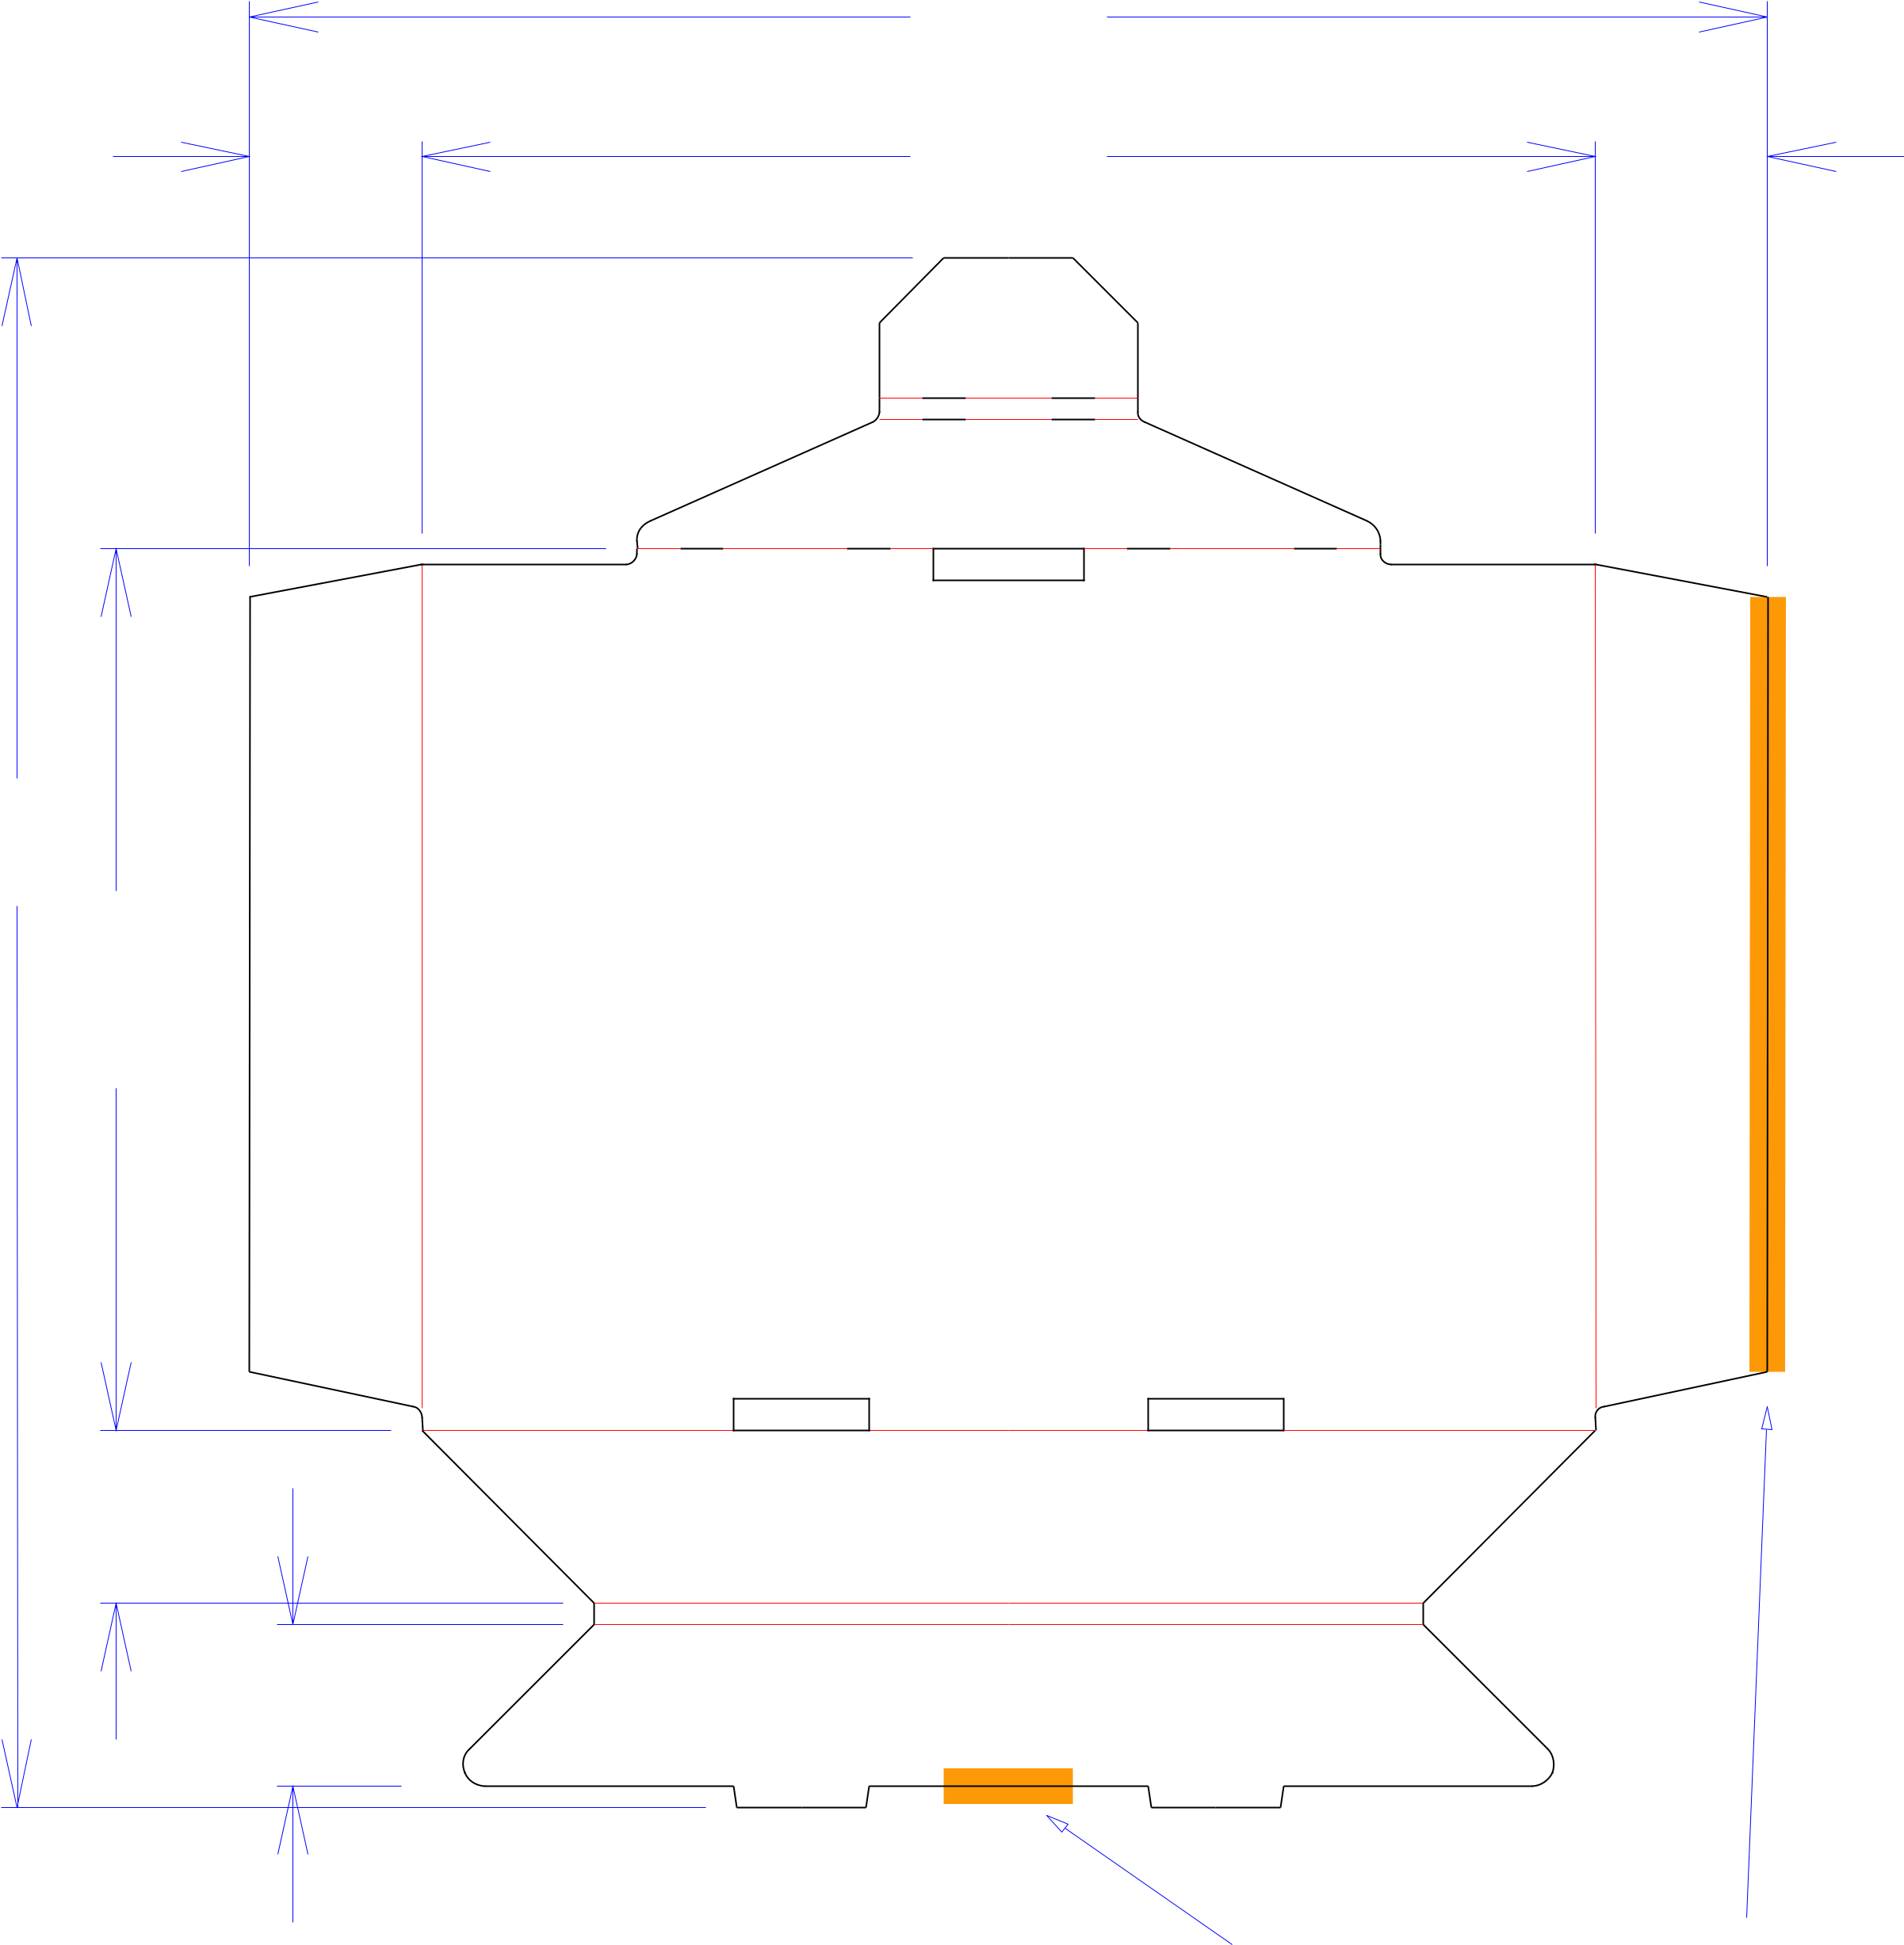

Design#:

**160923-02**

Customer:

**DeMet's Candy**

Description:

**Shelf - 40ct 7.5oz Flipz Display**

**SINGLE-OUT DRAWING**

Qty/Unit: **5 Per Display**

Style: **NJDC**

Board: **32BCT**

Combination: **37CT - 23M - 35HP**

I.D. : **13+7/8 x 9+7/8 x 50**

Area of Blank - Waste : **1.64 sq. ft.**

Waste on Blank : **25.35%**

Finished Piece Weight: **0.17 lbs./79.02g**

Over-all Blank: **18 x 175/8**

|  |
| --- |
| 2 |

|  |
| --- |
| 17*/*8 |

Notes:

Revision Info:

|  |  |  |  |  |  |  |  |  |  |  |  |  |  |
| --- | --- | --- | --- | --- | --- | --- | --- | --- | --- | --- | --- | --- | --- |
|  |  |  |  | BUNDLE BREAKER RULE | | | | | | | | | Designer: |
| Cut | Crease | Crease with Matrix | Cut Crease | Half Knife Cut | Tear Tape | | | | | | | | Perforation |
|  |  |  |  |  |  |  |  |  |  |  |  |  |  |



Designright and Copyright of DS Smith Corrugated Packaging Ltd. This technical Specification is subject to Manufacturing tolerances. Drawing dimensions shown are crease to crease. Date printed: 07/03/2018